Software engineering for big data analaysis

CSA-1035

EXP NO: 4

4. Draw a USE-CASE diagram for the Hospital Management System. The activities of the hospital system are listed below. Receive the patient id, Patient name, pharmacy, laboratory, doctor, administrator, record officer, test report, drug management, test management, user management, dispense drug using CASE tools

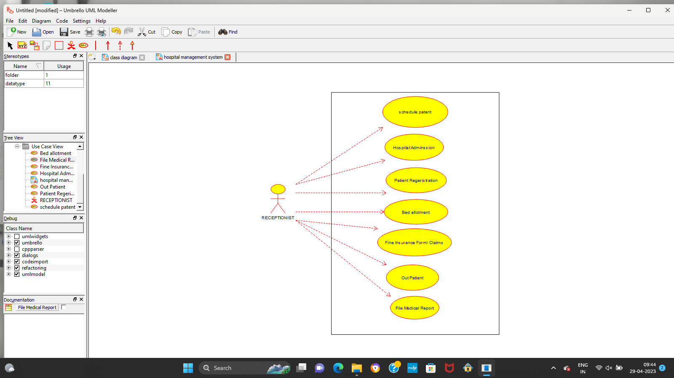

Result:-

Thus the use-case diagram for Hospital management is drawn and verified successfully.